BAND ROYALTY
by Kaity Woods
Miss Jessey Martin and Mr. D.J. Toelle were named Band Royalty prior to the annual Christmas program on December 9. Other attendants were Keeley Horning, Katie Davis, Blake Bower, and J.J. Stubblefield. The kindergarten attendants were Kenzie Miller and Joshua Barnes.

STATE CHAMPS – AGAIN!
The Pride of KHS Marching Band won its second marching band title in four years as they received a I at Regional and participated in the state contest at Lawton where they won the title in Class 2A.
Congratulations Band and Mrs. Toelle. KHS also won in 2011 when these seniors were freshmen.
Trivia Challenge 2015
The 26th annual KHS Trivia Challenge – a fun event for teams of adults from all over NW Oklahoma – will take place this spring. Watch for more information in the Enid News and Eagle and also a later edition of THE BRONC.

Superintendent’s Report
by Mr. Patton
As for the bond issue, initial funding for the first year is in place. Plans for the new building are being refined and working toward completion. Several adjustments have been made as teachers and others have had input into the design. The heating and air conditioning of the gymnasium is first priority in the planning. Also, Oxbow Calcining has donated money for the purchase of a new scoreboard for the gymnasium. It will be installed later in the spring.
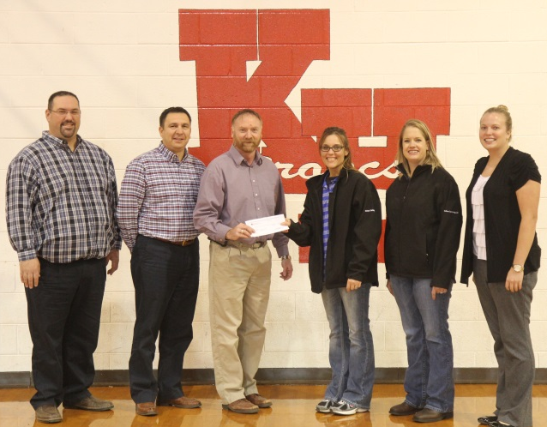
Mr. Patton accepting check for new scoreboard from Oxbow Calcining representatives, Bonnie Espinoza and Trinity White.
Also pictured: Mr. Brashears, Mr. Hawkins, and Ms. Turney
Band King D.J. and Queen Jessey

Mind Games
KHS academic team appeared on KSBI-TV, Channel 52, on the game show “Mind Games” on Sunday night, Dec. 14. KHS played Garfield County rival Drummond and lost on the last question, 305-330. However, since KHS answered the OK History question correctly, they brought home $545 for the academic team, thanks to the Chickasaw Tribe and Ward Petroleum. See some on-set pics on the next page.

REGIONAL CHAMPS
The KHS academic team won the Regional Tournament at Kremlin on Saturday, November 15, by beating Taloga, Cimarron, and Pond Creek-Hunter. KHS will also host the Area Tournament on January 17. Eight teams will vie for two spots at State in El Reno on Feb. 7. KHS avenged an earlier loss to Cimarron by beating the Trailblazers in the second round at Regionals. KHS now has a record of 23-8. See page two for other academic bowl news.

MIND GAMES
KHS was definitely the best-dressed team in the competition!
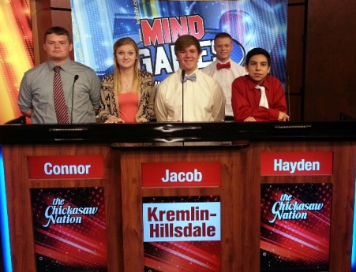
l-r: Connor Snapp, Jordan Presley, Jacob Pekrul, Hayden Bonine, Zeb Hawkins

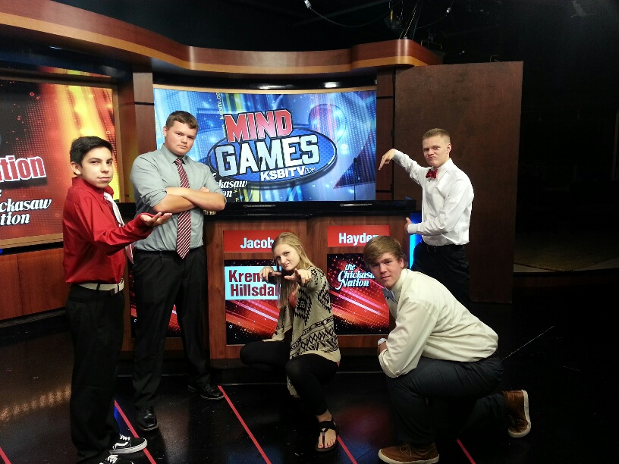
Zeb, Connor Jordan , Jacob, Hayden

Academic team competes in Bulldog Invitational at Edmond Memorial
KHS travelled to Edmond, OK, on Saturday, December 6, to compete in the Bulldog Invitational. KHS defeated Putnam City North, then lost to Edmond North, then beat Enid High in sudden death before losing to Plainview A to complete the preliminary rounds. After lunch, KHS participated in the small school (A-4A) division, defeating Plainview B. Plainview A beat KHS again to take the small school title. KHS finished second and had a 3-3 record overall.

5th/6th grade academic team takes
Top seed at Districts
KHS went to Canton for the OJABA (Oklahoma Junior Academic Bowl Association) district competition in Class A. KHS beat Canute 310-190 but lost to Canton 260-280. Because each team beat the other and all finished with 1-1 records, the district top seed was decided by total points scored. KHS finished with 570 to take first.
Rachel Reimer led the scoring with 160 points. Katy Brashears (60), Cooper Coffey (30), Kaylynn Brownell(10), Trace Henry (10), Harris Keithly (10), Andy Lockhart (10), and Ethan Haggard also played for the Broncs. Roger Gossen is team coach. The team will advance to Regionals at Canton on January 31.

Academic competition heats up in January
KHS Varsity academic team has three tournaments in January: NOC-Tonkawa Invitational on January 8, Area tournament at KHS on Jan. 17, and the Cherokee Strip Conference tournament at KHS on Jan. 26. All the OJABA junior high teams play also, starting with the 6th/7th grade team at Cimarron on Jan 7; 7th/8th team at KHS on Jan. 14; 8th/9th grade team at Cherokee on Jan. 19; 5th/6th team at Regionals at Canton on Jan. 31. Regional and State tournaments for all levels will be in February, March, and April.

Parents & patrons are always welcome to attend any KHS academic meet. They are fun and exciting!

Semester test days
by Joshua Reimer
The high school will be taking semester tests December 15-18. Red block study day is Monday and the test is Wednesday. White block study day is Tuesday and the test is Thursday. Junior high even and odd semester tests are on December 16 and 17. Odd tests are on Tuesday and even tests are on Wednesday

10th grade news
by Nicole Morse
The 10th grade class is selling Christmas ornaments for $5. The class is ready for Christmas break. The sophomore class also is having a special fundraiser at home basketball games. Patrons can buy a ticket for $5 (or five for $20). One ticket will be drawn at halftime of the boys game. The person whose ticket is drawn gets three chances to make a free throw; two chances to make a three-point shot; and one chance to make a half-court shot. If the person makes all three, that person will win a 42” HD television set!
Ninth grade news
by Alice Keithly
The ninth graders have been very busy this semester. They have started winter sports and have gone to state in band. They received first place in Class 2A with band.
Basketball season has begun. Both teams are working very hard.
The ninth graders are busily preparing for semester tests and are ready for Christmas Break. Also, the band put on the Christmas program on December 9, 2014 at 6:30 thankful for all the people who came out to support the Bronc band.
The ninth graders are looking forward to the close of the first semester and hope for a great year.

Sixth grade news
by Rachel Reimer
Swish! A sound we have all heard these past weeks as the ball goes into the basket. The fifth and sixth grade girls basketball team has been working hard and won their last game against Hillsdale-Christian. The boys have also been working hard at basketball.
On December 3, the fifth and sixth academic team went to Canton for districts, and played Canton and Canute. We played Canute first and won. Then we played Canton and lost, but we are still going to regionals on January 31, 2015. The sixth graders on the academic team are Rachel Reimer (captain), Katy Brashears, Cooper Coffey, Trace Henry, and Kaylynn Brownell. Joining them are fifth graders Ethan Haggard, Harris Keithly, and Andy Lockhart. Sixth graders Rachel Reimer and Cooper Coffey are also on the sixth/seventh grade team, which will be going to districts on January 7, 2015.
On December 9, the fifth and sixth band played “Ode to Joy” and “First Holiday Concert” in the Christmas program. We played very well for half of us starting at the beginning of the school year.
The sixth graders are looking forward to Christmas break, so we will see you in 2015.
Seventh grade new
by Morgan Miller
Hello Kremlin! It’s almost Christmas and that means no school until 2015! Basketball has started and ju. High is doing great so far! Ms. Turney and Mr. Hawkins are doing amazing!
Everybody is ready for school to get out I’m sure, but before we go we still have lots of tests. Many of our junior high were on the good standing list and we are very proud of them. Have a Merry Christmas and a Happy New Year!

Elementary news
by Zeb Hawkins
The monthly Bronc Rally held this December gave the chance for the Kindergarten to sing for the entire elementary. The star students were also recognized and awarded. The star students were Conner VerSchuer, Lanie Atherton, Aidyn Seek, Dixielee Pekrul, Alina Wolfe, Jaleigh Jacobs, and J.D. Felber. The essential rules were taught to the students all nine weeks. The rules are “Open the door for others” “Pick up your trash” and “Be accepting of others”. These rules have been very helpful to the learning students of the elementary.

Bronc Pride Day
by Cherokee Minter
On the day of December 12th, 2014, Kremlin Hillsdale held Bronc Pride Day for the 68 “students in good standing.” They went to the mall and watched the movie “Penguins of Madagascar.” Afterwards, the students ate sub sandwiches and strolled the mall before heading back to school. KHS has Bronc Pride Day every 9 weeks to reward the students in good standing for the good job they are doing. .
Blood drive
by Cherokee Minter
On the day of December 10, 2014, Kremlin Hillsdale School held a blood drive to get people to come out and donate blood to help save lives. You must be at least 17 without parent consist and 16 with parent signature. You also will need to bring a photo ID that presents your age. If you are a senior and in high school and you give blood 6 times before you graduate, you can sign up for honor cord and wear it on the night of graduation. We currently have two seniors already that have reached the amount to get honor cord and they still give blood to this day. The two seniors that have already made the honor cord are Zane Maner and Austyn Creel.

High-school band
by Kaity Woods
It’s been a busy year for High School band. To start off we won first place at state marching in Lawton.
D.J. Toelle was named to small school All-State concert band. He got 8th out of 160 of the state’s top 1A, 2A, 3A trumpet players. D.J also made 5A and 6A All-state jazz band. He was the only student from any 2A and 3A schools to make it. Out of 110 they only take five and he made it. He’ll perform at state music ed convention in January.
Clinic and concert band will be in February at OCU. Alice, D.J. and Bradie Gray made Red Capet All-Area Honor Band. Clinic and concerts for this band will be in January.
BUY BAND BUCKS at
JUMBO FOODS!

FFA News
by Josh Streck
National FFA was a success; we stopped in Nashville, TN, and saw the Country Music Hall of Fame, the Ryman Auditorium, and the Grand Ole Opry. Then we stopped in Bowling Green, KY, at the National Corvette Museum and then went to convention and career show and then we went to the Louisville Slugger Museum and lastly we stopped in Springfield, MO, at the Bass Pro Shop. Members that attended are Shilo Cline, Carlee Salisbury, Gabby Morris, Josh Streck, and Seth Schrader. Made for excellence is in Oklahoma City on December 13-14 (8th-10th grade), and Advanced Leadership Development is in Oklahoma City on December 13-14 (11th-12th grade). The Oklahoma Youth Expo swine nomination kits needed to be turned in to Mr. Goyen by noon on December 11th.The state officer Goodwill Tour is January 20-29. The NOC Tonkawa FFA Interscholastics is on January 28th. National FFA Week is February 21-28. FFA day at the capitol is February 16th.

National Honor Society
by Alice Keithly
The National Honors Society is involved in many things in our school, such as volunteer work, Red Ribbon Week, concession stand, and the blood drive. Mr. Gossen is the adviser, and the officers are: President- John Schrader, Vice President- James Olmstead, Secretary- Hayden Bonine, Reporter- D.J. Toelle, and Stuco Representative- Cheyenne Roche. The members are Katie Davis, Jacob Pekrul, Kass Bittle, Rebekah Gannon, Mary Mitchell, and Connor Snapp.
Potential new members will begin the process of applying for membership in the spring with an induction of new members in May, 2015.

WINTER FORMAL
by Emily Felber
Winter formal will be January third from seven to eleven thirty. Dinner will be from seven to eight. Winter formal is for grades ninth through twelfth. The DJ will be the same one that was used last year.

Yearbook
by Zeb Hawkins
These nine weeks the yearbook staff has been busy finishing up the fall sports for the yearbook. We are very excited to share them with you in the upcoming year. The time has come to begin to order them. If you are interested in ordering a yearbook call Mrs. Edington, head of the staff. We also would like to thank everyone who bought one last year and bought ads to be placed in the yearbook. If you have a picture you think belongs in our yearbook you can upload it yourself to ReplayIt.com. It even has a smartphone app, for the busy holiday pictures.
4-H news
by Emily Felber
At the last meeting the 4-H members packed Thanksgiving baskets. In October, they had 4-H week and made the teachers breakfast. They “adopted” the first child born in 4-H week into 4-H by giving the parents a basket of green baby clothes. Also in October they went trick-or-treating for cans. The new officers for 4-H are: president Natalie, vice president Taylor, reporter Kelsie, secretary Taryn, treasure Bailey and, song and game leaders are Aundrea and Dayla. In the month of December they have rung bells, went shopping for presents for the operation angel child, and on the 16th they had their Christmas party. They are working hard to live by their motto, “To Make the Best Better.”
Ag Boosters
by Nicole Morse
There are no upcoming events anytime soon. Just a reminder that every third Wednesday of the month there will be a meeting in the Ag room!

Band Boosters
by Gina Pekrul
Band Boosters are selling Gift Cards at home basketball games. They will be selling Valentines packages in February.

Lions Club
by Alice Keithly
“The Lions Club does things such as community service, keeping gate at games, the eyeglasses donation, and the Pancake Supper”, says Mr. Brashears, a member of the Kremlin Lions Club. When asked how he became involved, he said, “I talked a lot at their meetings about our school. My dad was a member, and I wanted to give back to the community.” If you see a Lions Club member, please thank them for the community service they do around Kremlin.
Stuco news
by Kalli Rundle
We have been making signs for the food drive and counting cans. We are getting ready for Winter Formal by making posters. Soon we will start decorating. Winter formal is January third. We had delegates that went to Stuco state and we are trying to improve this school day by day
F.C.A. Dallas Trip
by William Dunlap
On November 1, 2014, a group of nine senior boys led by Mr. Gossen went to Dallas to watch the Dallas Cowboys take on the Arizona Cardinals. Among the seniors were Andre Lizar, Antwon Lizar, D.J. Toelle, Jacob Pekrul, William Dunlap, James Olmstead, Rustin Pierce, Hayden Bonine, and John Schrader. We all stayed at the Double Tree by Hilton in Irving, Texas. We stay up until 3:00 am playing games and telling jokes. For dinner all of us had In-n-Out Burger and challenged each other to eat pepperoncini peppers. On Sunday morning, we held a small church service at 9:00 am;. afterwards we went to Denny’s for breakfast and left for AT&T Stadium. We arrived and found our seats where we all watched the game on both the field and the amazing JumboTron. After the game was over the entire group took pictures and left. We headed home on a 6 hour trip and we arrived at 10:30 pm

WildHorse Gang news
by Emily Felber
December fifth the WHG helped out with the Integris Christmas dinner. Everyone that helped got thirty dollars in tips a piece. They will be helping out with the Dillard’s Christmas ballet and participating in the Dillard’s fashion show. Recently one of the members went on a trip to the Provo Children’s Home in Caicos. Josiah helped the children with their school work and chores. He helped to organize the supply room for them and cooked a few meals for them. Many churches in Enid helped to raise money to buy a new washer and dryer for the home. One Bible study sent clothes for the children. This home is clean and is a donation supported place that takes in orphans and makes them feel like a family again. These children are doing their best to live normal lives and the head of the home, Miss Ashley, is doing her best to help them. Josiah told me that he became really great friends with three of the kids living there. There are seven kids living there right now. The oldest of the kids is seventeen and the youngest is seven. Josiah called these children, Children of the One True King
The WHG is also doing a project called the Red Bow campaign. They are doing their best to improve their community and their life.

S P O R T S

KHS football
by Chase Minter
The Broncs finished the season with a record of 4-6. On senior night, the Broncs beat Canton 78-48 . The seniors were Jacob Woodall, Andre Lizar, Austyn Creel, Blake Bower, Antwon Lizar, Zane Maner, Austin Brewer, Jacob Pekrul, Jadrien Stubblefield, and John Schrader.

High school boys basketball
by Coach Hawkins
The HS boys basketball season is getting into full swing. It has been a rough start playing five of their first six games on the road. The boys started the season with losses at Garber 52-26, at Burlington 45-57, and at Ringwood 54-67. The first win of the season came at home against Timberlake with Hayden Bonine hitting a last second shot to win the game 38-35. The Broncs traveled to Mullhall-Orlando losing 26-37. The Broncs picked up their second win at the Pond Creek-Hunter tournament beating DCLA 43-27. The boys are playing hard, playing together, and improving with each game. The seniors are Andre Lizar, Rustin Pierce, J.J. Stubblefield, Jon Schrader, James Olmstead, Zach Webber, and Jacob Pekrul. The juniors are Kass Bittle, Eli Voth, and Hayden Bonine. The sophomores are Jacob Buck, Brayden Bench, Joe Keithly, Casper Ramirez, and Briley Craig. The freshmen are Dakota Gabriel, Cody Bower, and Beau Brownell. Head Coach: Brad Hawkins, manager: Antwon Lizar, and stats: Zipporah Hawkins.

High school girls basketball
by Josh Streck
The coach is Tana Turney. There are 14 girls on the team. There is one senior on the team, Katie Davis. The juniors are Cheyenne Roche and Mary Mitchell. The sophomores are Madison Roberts, Rebecca Wasson, Carlee Salisbury, Jordan Harris, and Kalli Rundle. The freshmen are Jazzy Stubblefield, Hannah Carson, Caitlyn Henry, and Mahayla Mitchell.

Junior high boys basketball
by Coach Hawkins
The junior high boys basketball team is 3-6. The 7th graders are Miguel Rodriguez, Kody Thornton, David Schrader, Tristin Lockhart, Elijah Espinoza, Dalton McAlister, and Tyler Machia. The 8th graders are Brad Machia, Austin Ellis, Bobbie Gray, and Draden Stallings. Head coach: Mr. Hawkins.

Junior high girls basketball
by Josh Streck
There are 17 girls on the team. The players are Megan Carson, Dayla Anderson, Gracie Vandiver, Kenna Lam, Shayla Cline, Makayla Ratzlaff, Taylor Parrish, Ellen Benton, Zipporah Hawkins, Michelyn Stevens, Hope Ellis, Malia Voth, Daylan Dulinsky, Hannah Rundle, Demi Suitor, Haley Roche, and Destinee Bell.

Elementary boys basketball
by Chase Minter
The elementary boys are 2-9. They are working hard to improve their record by working hard each day. There are 19 players on the team. The 6th graders are: Logan Baker, Tony Bell, Cooper Coffey, Trace Henry, Bailey Hoeltzel, Robert Newberg, Nicholas Snodgrass, Andrew Wheeler, and Matt Wheeler. The 5th graders are: AJ Bell, Kade Couchman, JD Felber, Garrett Gorman, Ethan Haggard, Harris Keithly, Trevin King, Andrew Lockhart, Daytona Ratzlaff, Caden Russell.

Staff of THE BRONC
THE BRONC is being produced the Mr. Gossen’s Study Skills Class this year. Members of the class are: Emily Felber, William Dunlap, Zeb Hawkins, Alice Keithly, Chase Minter, Cherokee Minter, Nicole Morse, Josh Reimer, Josh Streck, and Kaity Woods. Roger Gossen is faculty advisor for THE BRONC. This paper is published at least once a quarter. It is provided online at no charge. If you need a printed copy, send $5.00 to THE BRONC staff, 705 5th Street, Kremlin, OK 73753.

BRONC Calendar 2014-2015
by William Dunlap
Dec. 15 Elem/JH BB vs Cherokee, 4:30 pm
Dec. 16 HS BB vs Covington, 6:30 pm
Dec. 17-18 Semester Exams
Dec. 18 Elem/JH BB at Garber, 4:30 pm
Dec. 19 Professional Day – No School
Dec. 19 HS BB vs. DCLA @ Lamont, 6:30 pm
Dec. 22 – Jan. 2 Christmas Break
Jan. 3 Winter formal
Jan. 5 First Day of Second Semester
Jan.5 Elem JH BB vs Medford, 4:30pm
Jan.6 JH/HS BB vs Lomega, 4:30 pm
Jan.7 Yearbook/ BB picture day
Jan.7 .6th/7th District academic tournament at Cimarron, 1 pm
Jan.8- 10 HS BB @ Cherokee Tournament
Jan.8 NOC Tonkawa invitational academic bowl
Jan. 12 Elem/JH BB @ Aline-Cleo
Jan. 13 HS BB @ Medford
Jan.14 Elem BB vs Covington-Douglas, 12:30 pm
Jan. 14 7th/8th District academic bowl, 1:00 pm
Jan. 15 4-H Meeting 3:30 pm
Jan. 15 Elem/JH BB @ Deer Creek
Jan. 16 Red Carpet Honor Band Clinics and Concert
Jan. 17 AREA Academic Bowl Tournament, 11:00 am
Jan. 19 8th/9th District academic Bowl at Cherokee, 4 pm
Jan. 21 FFA Booster Club meeting, 6:30 pm
Jan. 22-24 Cherokee Strip Conference Basketball Tournament
Jan. 23 Professional Day, NO SCHOOL
Jan. 26 HS Academic Bowl – Cherokee Strip Tournament
Jan. 26, 29, 31 Medford JH Basketball Tournament
Jan. 27 HS BB vs Cherokee, 6:30 pm
Jan. 30 HS BB vs Aline-Cleo, HOMECOMING
Jan. 31 5th/6th Regional Academic Bowl Tournament at Canton, 10 am
Feb. 6 HS BB vs Cimarron
Feb. 7 HS State Academic Bowl Tournament at El Reno, 10 am
Feb. 9 HS BB at Drummond
Feb. 10 HS BB vs Waukomis
Feb. 12-14 District BB Tournament
Feb. 12 Parent-Teacher Conferences, 4:00 pm – 8:00 pm
Feb. 13 Parent-Teacher Conferences, 8:00 am – 12 noon, NO SCHOOL
Feb. 16 Professional Day, NO SCHOOL
Feb. 19-21 Regional BB Tournament
Feb. 21 7th/8th Regional Academic Bowl at Vici
Feb. 26-28 Area BB Tournament
Feb. 28 6th/7th Regional Academic Bowl at KHS
Mar. 5-7 State Basketball Tournament
Mar. 6 Close of the third nine weeks
Mar. 7 8th/9th Regional Academic Bowl at KHS
Home events are in BOLD

Bronc Booster news
by Tina Lunday
We are looking for you!!! Sign up today to be a Bronc Booster and help support our student athletes. Contact any current member for more information or look for us to have a table set up at home basketball games starting in Januaryh. We will have our winter Bronc Gear available to order at home basketball games as well. We look forward to seeing you.

Merry Christmas and a Happy New Year from all of us at KHS!

